Eagle Scout/Gold Award Certificate of Achievement
 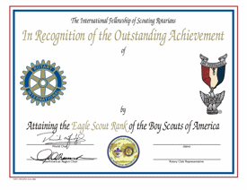 /  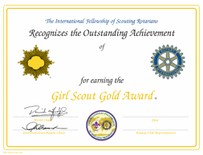

Rotary International – District 7510

Serving the New Jersey Counties of HUNTERDON, MERCER, MIDDLESEX, SOMERSET, and UNION
In Cooperation with the International Fellowship of Scouting Rotarians

Certificate Presentation Request

Recipient Name (please print exactly as desired on certificate, including spaces & punctuation):

Circle One: BSA GSUSA Troop No: _____ Council: ___________________________

COUNTY: [ ] HUNTERDON [ ] MERCER [ ] MIDDLESEX [ ] SOMERSET [ ] UNION

Court of Honor Day/Date ____________________________ Time _____ [ ] AM [ ] PM

Place __________________________________________________________________

Address _____________________________________ City ______________ ZIP _____

Unit Contact ______________________________ Position ______________________

Address ________________________________________________________________

Preferred Phone ___________________________ Fax __________________________

E-Mail Address ___________________________________________________________

Please Mail or E-Mail this Request to:

Hal Daumé, Scouting Services Chair - Rotary International District 7510
31 Berkeley Square - Berkeley Heights - New Jersey 07922
haldaume@incg.org - Phone [908] 447-6290



PLEASE SEND THIS FORM AT LEAST 2 WEEKS BEFORE COURT OF HONOR!

